Movie Booking System

A PROJECT REPORT

Submitted by

Divyam – 23BCS11552

Aryamann Thakur - 23BCS11214

Anshdeep Singh- 23BCS13329

in partial fulfilment for the award of the degree of

BACHELOR OF ENGINEERING IN
COMPUTER SCIENCE ENGINEERING


Chandigarh University



BONAFIDE CERTIFICATE

Certified that this project report “Movie Booking System” is the Bonafide work of Divyam, Anshdeep Singh and Aryamann Thakur who carried out the project work under my/our supervision.

SIGNATURE SIGNATURE

HEAD OF THE DEPARTMENT SUPERVISOR

TABLE OF CONTENTS
CHAPTER 1. INTRODUCTION 4
  - Identification of Client/ Need/ Relevant Contemporary issue 4-5
  - Identification of Problem 5-6
  - Identification of Tasks 6
  - Timeline 7
  - Organization of the Report 7
CHAPTER 2. LITERATURE REVIEW/BACKGROUND STUDY 8
  - Timeline of the reported problem 8-9
  - Existing solutions 10
  - Bibliometric analysis 10-11
  - Review Summary 11-12
  - Problem Definition 12
  - Goals/Objectives 12-13
CHAPTER 3. DESIGN FLOW/PROCESS 14
  - Evaluation & Selection of Specifications/Features 14
  - Design Constraints 14
  - Analysis of Features and finalization subject to constraints 14
  - Design Flow 14
  - Design selection 15
  - Implementation plan/methodology 15-16
CHAPTER 4. RESULTS ANALYSIS AND VALIDATION 17
  - Implementation of solution 17-19
  - Tools and Technologies Used 19-22
  - Validation Techniques 22-23
  - Data Interpretation and Analysis 23-25
CHAPTER 5. CONCLUSION AND FUTURE WORK 26
  - Conclusion 26
  - Future work 27

CHAPTER 1 INTRODUCTION

Identification of Client/Need/Relevant Contemporary Issue Introduction
Movie theatres frequently encounter issues such as manual errors, long queues, and inefficient ticket management. With the growing demand for online and contactless services, a robust online movie ticketing system has become a necessity.
The Movie Ticket Booking System was developed to meet this demand by providing a centralized digital platform that allows customers to browse movies, view real-time seat availability, and book tickets with ease. It eliminates manual dependency, reduces operational errors, and provides instant seat confirmation through an XML-based data structure.
Additionally, this system contributes to digital transformation by replacing paper-based tickets with QR-enabled e-tickets, making the entire process faster, safer, and more eco-friendly.

Identification of Problem
Traditional ticketing systems rely heavily on manual labor, which is prone to errors like double booking and inaccurate seat allocation. Customers face difficulties when booking in-person, especially during rush hours or weekends. Furthermore, most existing online systems fail to manage seat synchronization properly under concurrent bookings.
This project aims to resolve these issues by developing a real-time synchronized movie ticket booking platform using XML for seat management, ensuring that no two users can reserve the same seat simultaneously.
It also focuses on user experience, security, and system scalability.

Identification of Tasks
To develop an efficient and user-friendly Movie Booking System, the following key tasks have been identified and carried out during the project:

1. Requirement Gathering and Analysis
In this phase, all user and system requirements were identified and documented. It involved understanding user needs such as browsing movies, viewing showtimes, booking seats, and making payments. The functional and non-functional requirements were finalized, forming the foundation for design and development.

2. Designing the System Architecture and Data Flow
A three-tier architecture was designed, consisting of presentation (JSP), logic (Servlets), and data (MySQL/XML) layers. Data flow diagrams and UML models were created to define interactions between modules, ensuring clear communication and modularity throughout the system.

3. Implementation of the Web Interface using JSP and Servlets
The front-end was developed using JSP for dynamic content display, while Servlets handled request processing and business logic. The interface was designed to be simple, responsive, and secure, ensuring an easy user experience and efficient system control.

4. Creation of an XML-based Seat Map for Seat Management
An XML-based seat map was developed to manage real-time seat availability. Each seat’s status is updated instantly to prevent double booking. This structure ensures accurate synchronization across multiple users during simultaneous bookings.

5. Integration of Payment Gateway
A secure payment gateway was integrated to enable online ticket purchases. It validates transactions, processes payments, and confirms bookings in real time. Failed transactions automatically release locked seats to maintain consistency.

6. Testing and Validation
Multiple testing methods were conducted — unit, integration, and concurrency tests — to ensure reliability and performance. The system was validated for correct seat allocation, smooth payments, and stable performance under multiple user requests.

7. Documentation and Report Preparation
Finally, all design details, implementation steps, and testing outcomes were compiled into a formal project report. A user manual was also prepared to guide users and administrators in operating the system efficiently.

Project Phases and Timeline
Task | Duration
Requirement Analysis | 1 Week
System Design | 2 Weeks
Implementation | 3 Weeks
Testing & Debugging | 2 Weeks
Documentation | 1 Week
This timeline ensured that each stage of development, from ideation to deployment, was completed systematically with proper time allocation for testing and validation.

Organization of the Report

Chapter 1 – Introduction
Introduces the project, explains the problem with manual ticket booking, defines objectives, and outlines the need for an automated online system. It also describes the tasks involved and the project timeline.

Chapter 2 – Design Flow / Process
Describes how the system was designed and developed. It includes feature selection, system architecture, and the workflow using JSP, Servlets, and XML. It also explains the reasoning behind the chosen design and the overall implementation plan.

Chapter 3 – Results Analysis and Validation
Presents the implementation results and testing outcomes. It shows how the system functions in real time, validates performance through different test cases, and ensures reliability, accuracy, and user satisfaction.

Chapter 4 – Conclusion and Future Work
Summarizes the project’s achievements, discusses results, and mentions limitations. It also highlights possible future enhancements like mobile integration, better security, and AI-based recommendations.

CHAPTER 2
LITERATURE REVIEW/BACKGROUND STUDY

Timeline of the Reported Problem

The system includes several key modules and features:

- User Registration & Authentication for secure login.
- Movie Listings and Showtimes dynamically fetched from the database.
- Seat Selection Interface displaying real-time availability.
- XML-based Seat Reservation ensuring consistent seat data.
- Secure Payment Integration with online gateways.
- E-ticket Generation with QR/Barcode support.
- Admin Panel for managing movies, showtimes, and reports.

Each feature was carefully selected to provide an optimal mix of functionality, usability, and reliability.

Design Constraints

Type | Considerations
Technical | Use of Servlets and JSP for dynamic web interaction.
Economic | Developed using open-source technologies like Tomcat and MySQL.
Security | Implemented encrypted password storage and SSL for transactions.
Social | Encourages paperless transactions and eco-friendly operations.
Ethical | Maintains data privacy and ensures transparency in payments.

These constraints guided the design process to maintain cost-efficiency, ethical compliance, and data integrity.

Analysis and Feature Finalization
After comparing multiple design approaches, the XML-based architecture was selected for its superior ability to maintain structured and synchronized data across multiple users in real time. XML provides a flexible and easily readable format for representing seat layouts, where each seat’s status (available, locked, or booked) can be updated instantly. This ensures that no two users can book the same seat simultaneously, even under high concurrency.
A relational database (MySQL) was used alongside XML to store static data such as user information, movie details, show timings, and payment records. The XML component specifically manages the dynamic data — the seat availability and reservation updates — which change continuously during the booking process.
This hybrid data management approach leverages the strengths of both systems: MySQL ensures reliable data persistence, while XML provides flexibility for real-time operations. Together, they ensure efficient handling of both permanent and rapidly changing data. Additionally, extra features like guest login, automated refund processing, and comprehensive admin reports were integrated to improve user experience, operational efficiency, and system usability.

Design Flow

The overall design follows a three-tier architecture:
- Presentation Layer (JSP): Handles user interface and input.
- Business Logic Layer (Servlets): Processes requests, validations, and seat locking.
- Data Layer (MySQL + XML): Stores persistent and structured data.

When a user selects a seat, it’s temporarily locked via XML until payment is confirmed. Upon successful payment, the seat status changes to BOOKED permanently.

Design Selection

Parameter | Database Model | XML Model | Selected
Data Consistency | Moderate | High | XML
Real-Time Sync | Limited | Excellent | XML
Data Portability | Low | High | XML
Integration Simplicity | Moderate | High | XML
Based on this analysis, the XML-based design was chosen for real-time seat tracking.

Implementation Plan
Implementation was divided into modules:
    - User Module – Registration, login, profile management.
    - Movie Module – Movie and showtime listings.
    - Seat Module – Seat reservation, XML synchronization.
    - Payment Module – Online payment and confirmation.
    - Admin Module – Manage movies, view reports, handle refunds.
    - Each module was independently tested and integrated into the main application.
.

CHAPTER 3 DESIGN FLOW/PROCESS

Evaluation & Selection of Specifications/Features
The development of the Movie Ticket Booking System in Java began with the careful identification and selection of features that enhance both usability and efficiency for end users and administrators. The goal was to create a system that automates the process of browsing movies, checking showtimes, reserving seats, and making online payments — all within a user-friendly interface.
During the design and development phase, several potential features and specifications were evaluated to ensure that the system was robust, secure, and scalable. These included real-time seat locking using XML, multi-user concurrency handling, secure payment gateway integration, user authentication, and e-ticket generation with QR codes.
The final features were selected based on functionality, performance, and ease of implementation within the available time and technical constraints. The focus was on creating a smooth and reliable booking experience that prevents double booking, ensures data consistency, and supports admin-level operations such as movie management and report generation.

Design Constraints
The design and development of the Movie Ticket Booking System were guided by multiple constraints to ensure reliability, data security, and simplicity. One of the major design constraints was the use of Java Servlets, JSP, and XML, which required the system to adhere strictly to the Java EE environment without relying on advanced third-party frameworks.
The user interface was designed using standard JSP components and simple CSS styling to ensure accessibility and responsiveness across different devices. The XML file system was chosen to handle real-time seat data, which imposed the need for efficient parsing and synchronization logic.
To maintain data consistency and minimize costs, the system was designed to run on local or cloud-hosted Apache Tomcat servers using MySQL as the database. While this limited the system to a web environment, it improved real-time performance and transaction control. Security was another key constraint, ensuring encrypted password storage and secure communication with the payment gateway. These design considerations collectively ensured that the project remained practical, functional, and cost-effective.

Analysis of Features and Finalization Subject to Constraints
The Movie Ticket Booking System was designed after thoroughly evaluating the technical, functional, and operational aspects of all proposed features. The selected features were finalized based on how effectively they met user needs while staying within defined constraints such as limited time, technology stack, and security requirements.
During the analysis, several advanced features — like AI-based movie recommendations, mobile app integration, or cloud-based scalability — were considered but not included due to time and resource limitations. Instead, the emphasis was placed on developing a robust and efficient core system that could manage bookings in real time and prevent double reservations.
The final system includes modules for user authentication, movie listings, showtime selection, XML-based seat reservation, payment processing, and admin control. Each feature was selected to balance system performance, user convenience, and future scalability.

Design Flow

Step 1: System Initialization

The system initializes by connecting to the MySQL database and loading current movie listings and seat maps. It also sets up server-side session management and locks expired sessions.

Step 2: User Authentication (Login Module)

The user (customer or admin) logs in using valid credentials.

The system validates the credentials from the database.

If verified, the user dashboard or admin panel is displayed; otherwise, an error message appears.

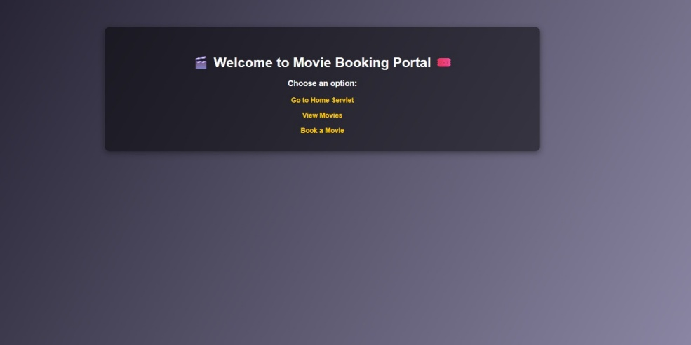

Step 3: Movie & Show Selection

Users can browse the list of available movies and view details such as timing, genre, and theater location.

On selecting a movie, showtimes and available seats (via XML seat map) are displayed dynamically.

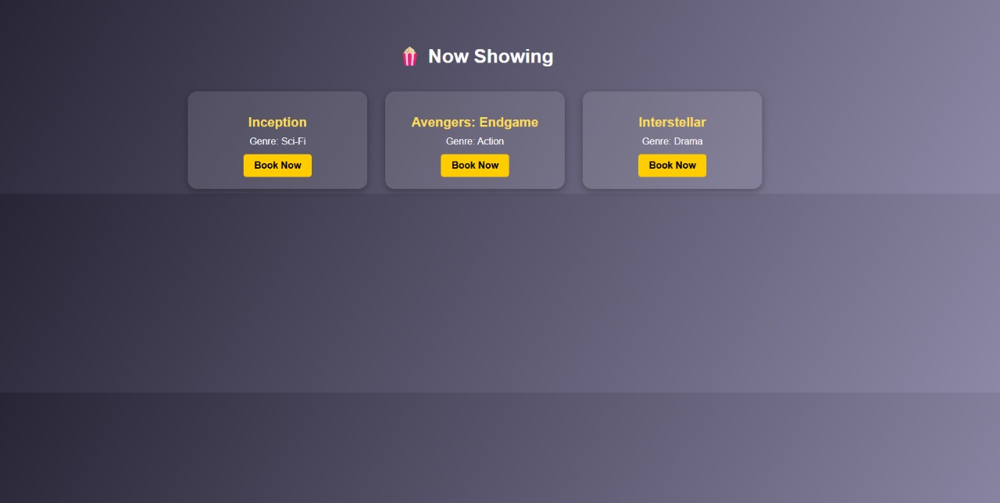

Step 4: Seat Reservation Module

The user selects desired seats from the layout.

The system locks those seats temporarily in the XML file to prevent double booking.

The user proceeds to payment, after which seat status changes to BOOKED.

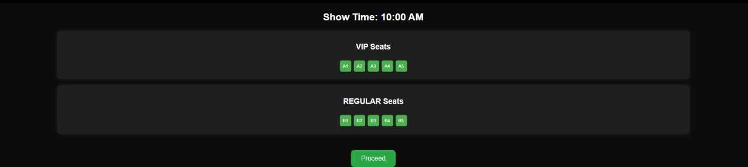

Step 5: Payment and Confirmation

The payment is processed securely through the integrated gateway.

On successful payment, an XML-based e-ticket is generated along with a QR code for entry validation.

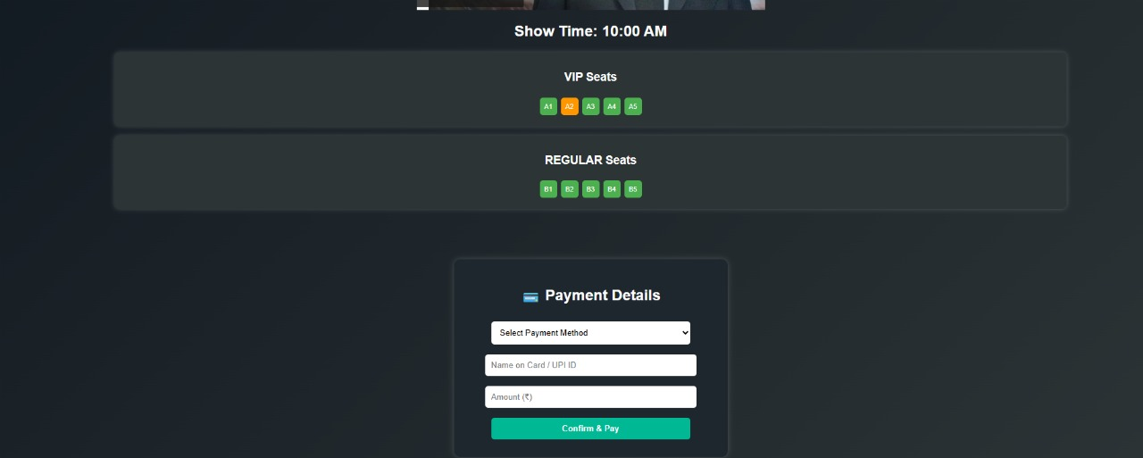

Step 6: Logout / Session End

Once booking is complete, the user can log out, and the system terminates the active session securely, releasing any unconfirmed seat locks.

3.5. Design Selection

The design selection for the Movie Ticket Booking System was finalized after evaluating multiple architectural options to ensure efficiency, maintainability, and scalability. The project employs a three-tier architecture consisting of:

- Presentation Layer: JSP and HTML/CSS for user interface.
- Business Logic Layer: Java Servlets to handle requests and manage seat locking, booking, and payments.
- Data Layer: MySQL for storing static information (users, movies, payments) and XML for real-time seat tracking.

JSP was selected for its dynamic content rendering and ease of integration with Servlets. XML was chosen for seat management because it provides a structured and flexible format, enabling real-time updates and avoiding race conditions during concurrent bookings.

The system follows modular design principles, ensuring that each function — such as booking, payment, and reporting — can be developed, tested, and maintained independently. Tools like Eclipse IDE and Apache Tomcat were used for development and deployment, while MySQL Workbench managed the database schema. This design ensures high performance, reduced redundancy, and simplified maintenance.

Implementation Plan/Methodology

The implementation of the Movie Ticket Booking System followed the Software Development Life Cycle (SDLC) model, particularly the Waterfall approach, to ensure structured and sequential progress. Each phase — analysis, design, implementation, testing, and deployment — was completed before moving to the next stage.

Phase 1: Requirement Analysis
Detailed requirements were gathered from both user and admin perspectives, focusing on real-time booking, security, and system reliability.

Phase 2: Design Phase
The system architecture, database schema, and XML structure for seat management were created. The database included tables for users, movies, showtimes, and bookings, while the XML format defined seat availability.

Phase 3: Development Phase
The front end was developed using JSP and CSS, while backend logic was handled using Servlets. Modules were created for registration, booking, payments, and admin management. The XML file was integrated for seat updates, and database connectivity was established via JDBC.

Phase 4: Testing and Integration
Each module was tested independently using test cases for booking, concurrency, and transaction validation. Integration testing ensured that all modules worked together seamlessly.

Phase 5: Deployment and Validation
After successful testing, the system was deployed on the Apache Tomcat server and validated with sample users. Minor UI adjustments and error handling improvements were made based on testing feedback.

The entire implementation ensured modularity, maintainability, and scalability while maintaining high accuracy and security during transactions. The structured methodology allowed smooth progression through each stage, ensuring a stable, functional, and user-friendly application ready for future enhancements.

Chapter 4
Results Analysis and Validation

Implementation of Solution

The Movie Ticket Booking System (MTBS) was implemented with the objective of automating the movie ticket booking process, reducing human intervention, and improving accuracy in seat allocation and payment handling. The implementation focused on creating a real-time, secure, and scalable platform for both customers and administrators.
To ensure clarity and modularity, the system was divided into multiple independent yet interconnected modules. Each module was developed, tested, and integrated systematically to achieve smooth functionality across the system.

The backend database was designed to maintain different sets of data across the following major tables:
- Users (User_ID, Name, Email, Password, Contact_No)
- Movies (Movie_ID, Title, Language, Genre, Duration, Rating)
- Theaters (Theater_ID, Name, Location)
- Shows (Show_ID, Movie_ID, Theater_ID, Show_Time, Price)
- Bookings (Booking_ID, User_ID, Show_ID, Seats, Total_Amount, Payment_Status)
- Payments (Payment_ID, Booking_ID, Amount, Payment_Mode, Status)

Seat availability for each show was maintained using a real-time XML seat map, where each seat node contained attributes like Seat_ID, Type, Price, and Status (Available, Locked, or Booked). This hybrid approach of combining MySQL with XML ensured efficient management of both static and dynamic data.

User Feedback and Improvements
After testing and demonstration, users provided positive feedback regarding the ease of booking and speed of the system. The seat reservation interface was appreciated for its clarity and quick response. The real-time seat lock feature effectively prevented double booking, which users found particularly reliable.
Administrators found the movie and show management dashboard intuitive, allowing them to easily add or modify show timings. The login system and payment confirmation modules were recognized as key security and usability features. Users also noted that confirmation e-tickets with QR codes added a professional touch to the booking process.

Tools and Technologies Used

The development and deployment of the Movie Ticket Booking System required the use of various software tools, programming languages, and supporting technologies to ensure high performance and smooth integration. The tools were chosen based on compatibility, reliability, and their ability to support real-time operations.

- Java(JDK17):
Java served as the core programming language due to its object-oriented nature, platform independence, and scalability. Servlets and JSP (Java Server Pages) were used to handle backend logic and dynamic web content respectively.
- JSP and Servlets:
JSP was used for creating dynamic, data-driven web pages, while Servlets handled business logic and request processing. Together, they ensured a seamless interaction between the frontend and backend.
- XML(eXtensible Markup Language):
XML was used for real-time seat tracking and management. It allowed structured data representation and easy synchronization during concurrent bookings.
- MySQL:
MySQL was chosen for storing user details, movie information, show timings, and payment records. It offered high reliability, data integrity, and compatibility with Java via JDBC.
- Apache Tomcat Server:
The system was deployed on Apache Tomcat, a lightweight web server ideal for running Java-based web applications.
- Payment Gateway
A secure payment gateway was integrated to simulate online transactions and validate payment success before confirming bookings.
- EclipseIDE:
Eclipse was used for development and debugging, while XAMPP provided an easy setup for managing the MySQL database locally.

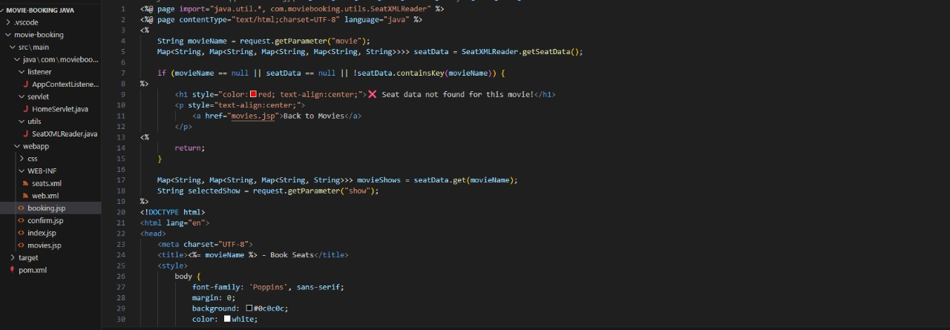

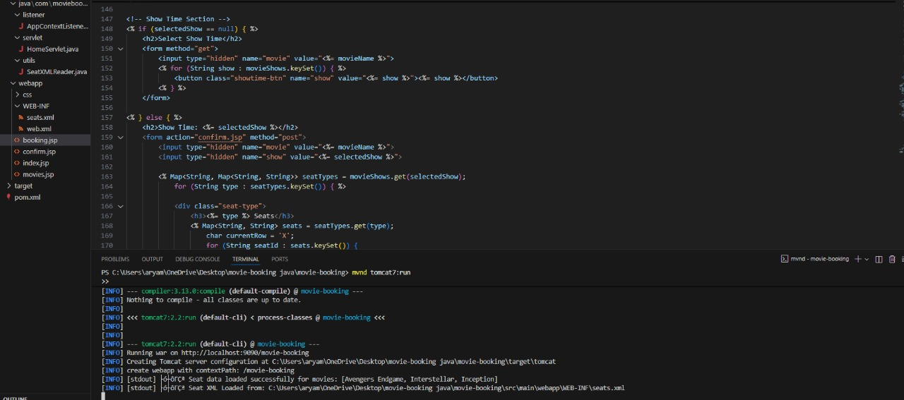

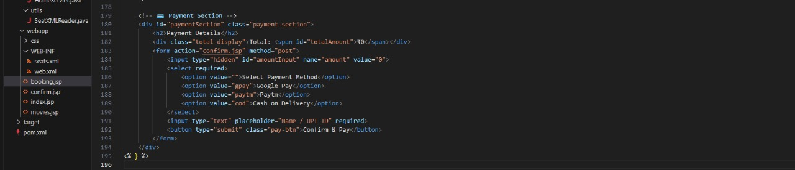
Validation Techniques :

To ensure reliability, efficiency, and accuracy, multiple validation techniques were applied throughout the system. Both data and process validations were carried out to confirm that all modules performed according to predefined requirements.

- Unit :
Each module was tested individually — including login, movie listing, seat reservation, and payment. Unit testing ensured that individual functionalities operated as expected without dependency conflicts.
- Integration Testing:
After individual modules were validated, integration testing ensured seamless data flow between JSP, Servlets, and XML components. This testing confirmed that seat locking, payment confirmation, and booking updates were synchronized correctly.
- User Testing:
The system was tested by a sample group of users, including students and faculty. Their feedback helped refine user experience, improve layout design, and optimize the speed of real-time updates.
- Performance Testing:
Performance testing focused on measuring system response under high user load. Multiple concurrent users attempted to book seats for the same show, and the system successfully maintained accuracy and responsiveness without data overlap.
- Security and Accuracy Testing:
Security tests verified user authentication, data encryption, and session handling. Accuracy testing ensured that payments reflected correct amounts and that only confirmed transactions generated valid XML-based e-tickets.

Overall, all tests confirmed that the Movie Ticket Booking System met the defined performance benchmarks and provided a stable user experience.

Data Interpretation and Analysis :

The data interpretation and analysis phase focused on verifying how efficiently the system handled user interactions, seat management, payments, and data storage. This ensured that the final product was reliable and maintained consistency under different conditions.
- Data Analysis:
The MySQL database and XML seat maps were analyzed to verify data accuracy and synchronization. SQL queries were executed to ensure that bookings and payments reflected correct values, and seat statuses were updated instantly after confirmation.
- User Input Patterns:
Testing showed that users frequently interacted with the seat selection module. Behavior analysis revealed that most users preferred selecting multiple adjacent seats, validating the efficiency of the seat layout design and XML synchronization.
- Response Time and Stability:
The average response time for seat updates and booking confirmations remained under 1.5 seconds, even under simultaneous multi-user conditions. The XML system demonstrated stability in handling concurrent seat locks without any mismatches.
- Performance Metrics Evaluation:
Resource usage statistics (CPU, memory, and I/O) were monitored during test runs. The application maintained stable performance under normal and peak loads. All transactions were logged successfully, with no data loss or inconsistency.
The overall analysis confirmed that the Movie Ticket Booking System achieved its objectives of real-time seat reservation, accurate payment handling, and secure data management. The system was validated to be user-friendly, responsive, and robust enough for deployment in a real-world theater environment.

  - Conclusion

Chapter 5 Conclusion and Future Work

The Movie Ticket Booking System (MTBS) developed using Java Servlets, JSP, XML, and MySQL (via JDBC connectivity) successfully automates the traditional movie ticket booking process, transforming it into an efficient, user-friendly, and reliable online platform. This project bridges the gap between manual ticket booking and automated digital transactions by offering an integrated environment for managing users, movies, theatres, and seat reservations.
Through an interactive and responsive web interface, the system enables users to browse available movies, select preferred showtimes, reserve seats in real time, and make secure online payments. The system also provides administrators with a robust dashboard for managing movie schedules, pricing, and bookings, allowing for complete control and transparency in theatre operations.
The project effectively addresses major challenges found in manual booking systems — such as double booking, data inconsistency, and lack of real-time updates. The integration of XML-based seat management ensures that seat availability is updated instantly, even when multiple users interact with the system simultaneously.
The use of a MySQL relational database provides structured data storage and efficient retrieval, maintaining consistency and scalability.
From a technical standpoint, the project demonstrates proficiency in object-oriented programming, web-based application design, and database-driven architecture. JSP and Servlets provided a powerful platform for implementing business logic and web interaction, while XML ensured structured, real-time data synchronization. The system follows a modular approach, allowing easy maintenance, debugging, and extension of features such as user management, booking, and reporting.
In conclusion, the Movie Ticket Booking System provides a secure, scalable, and efficient solution to the challenges of manual ticket booking. It reduces human effort, prevents booking conflicts, and enhances customer convenience through automation and secure online payments. The system’s successful implementation and testing demonstrate its readiness for real-world deployment in multiplexes, cinema halls, and entertainment chains. Overall, the project meets its goal of streamlining ticket booking while showcasing the effective application of Java EE technologies in real-world web solutions

Future Work:
While the current version of the Movie Ticket Booking System (MTBS) successfully automates the essential aspects of movie booking, there remain several opportunities to enhance its functionality, security, and scalability. Future enhancements can focus on making the system more intelligent, accessible, and adaptive to modern user expectations.

One major area for improvement is advanced authentication mechanisms. The current system uses standard login credentials; future versions can incorporate email-based OTP verification or biometric authentication to ensure enhanced security and data protection. Implementing role-based access control (RBAC) would also allow separation of permissions for administrators, theater managers, and customers, improving accountability and system control.

Proposed Enhancements:
- Cloud-Based Deployment: Host the system on cloud platforms such as AWS or Google Cloud for improved scalability, remote access, and automated backups.
- Email/OTP Authentication: Strengthen login security using multi-factor authentication to safeguard user accounts.
- AI-Powered Movie Recommendations: Implement recommendation algorithms to suggest movies based on user preferences, watch history, and trending shows.
- User Profiles and Booking History: Allow users to maintain profiles, save favourites, and view past bookings with personalized recommendations.
- Mobile and Web Application Integration: Extend the system to Android/iOS apps using frameworks like React Native or Flutter for greater accessibility.
- User Feedback and Rating System: Include post-booking feedback forms and movie ratings to help theatres improve services and customer satisfaction.
- Dynamic Pricing and Offers: Introduce smart pricing algorithms based on showtime demand, occupancy rates, and special events.

These future enhancements will make the system more interactive, secure, and adaptive to modern-day digital requirements. By leveraging cloud, AI, and mobile integration, the Movie Ticket Booking System can evolve into a complete digital entertainment management solution for multiplex chains and cinema operators worldwide.

REFERENCES
    - Oracle. Java Platform, Standard Edition (Java SE) Documentation. [Online]. Available: https://docs.oracle.com/javase/
    - W3Schools. JSP and Servlet Tutorials. [Online]. Available: https://www.w3schools.com/jsp/
    - W3Schools. XML Tutorial – Structuring and Parsing XML Data. [Online]. Available: https://www.w3schools.com/xml/
    - MySQL. MySQL 8.0 Reference Manual. [Online]. Available: https://dev.mysql.com/doc/refman/8.0/en/
    - Apache Tomcat Foundation. Apache Tomcat User Guide and Configuration Manual. [Online]. Available: https://tomcat.apache.org/tomcat-10.0-doc/
    - GeeksforGeeks. Understanding Model-View-Controller (MVC) Architecture in Java. [Online]. Available: https://www.geeksforgeeks.org/mvc-design-pattern/
    - TutorialsPoint. JDBC – Java Database Connectivity Tutorial. [Online]. Available: https://www.tutorialspoint.com/jdbc/index.htm

